Dual Prismatic Shield Channel
White Paper Proof of Concept for Paired Oscillating Prismatic Shield Corridors
Document Type | High-level shielding proof-of-concept white paper
Concept Thesis | Use two oscillating prismatic PTEC channels to form a paired electromagnetic corridor that feeds, balances, and strengthens a larger shield lattice.
Primary Use | Shield-lattice support, load balancing, field shaping, and localized reinforcement
Status | Concept architecture draft
Abstract
Dual Prismatic Shield Channel is a shielding support concept in which two oscillating prismatic PTEC nodes establish a paired electromagnetic corridor rather than a single isolated field path. The purpose of the corridor is not to replace all other shield structures, but to balance, distribute, and redirect field load across a broader defensive lattice. In this architecture, the prismatic pair acts as a feed-and-stabilization layer for hull nodes, prism arrays, or localized reinforcement zones, producing a more resilient shield envelope than a single static field path would allow.
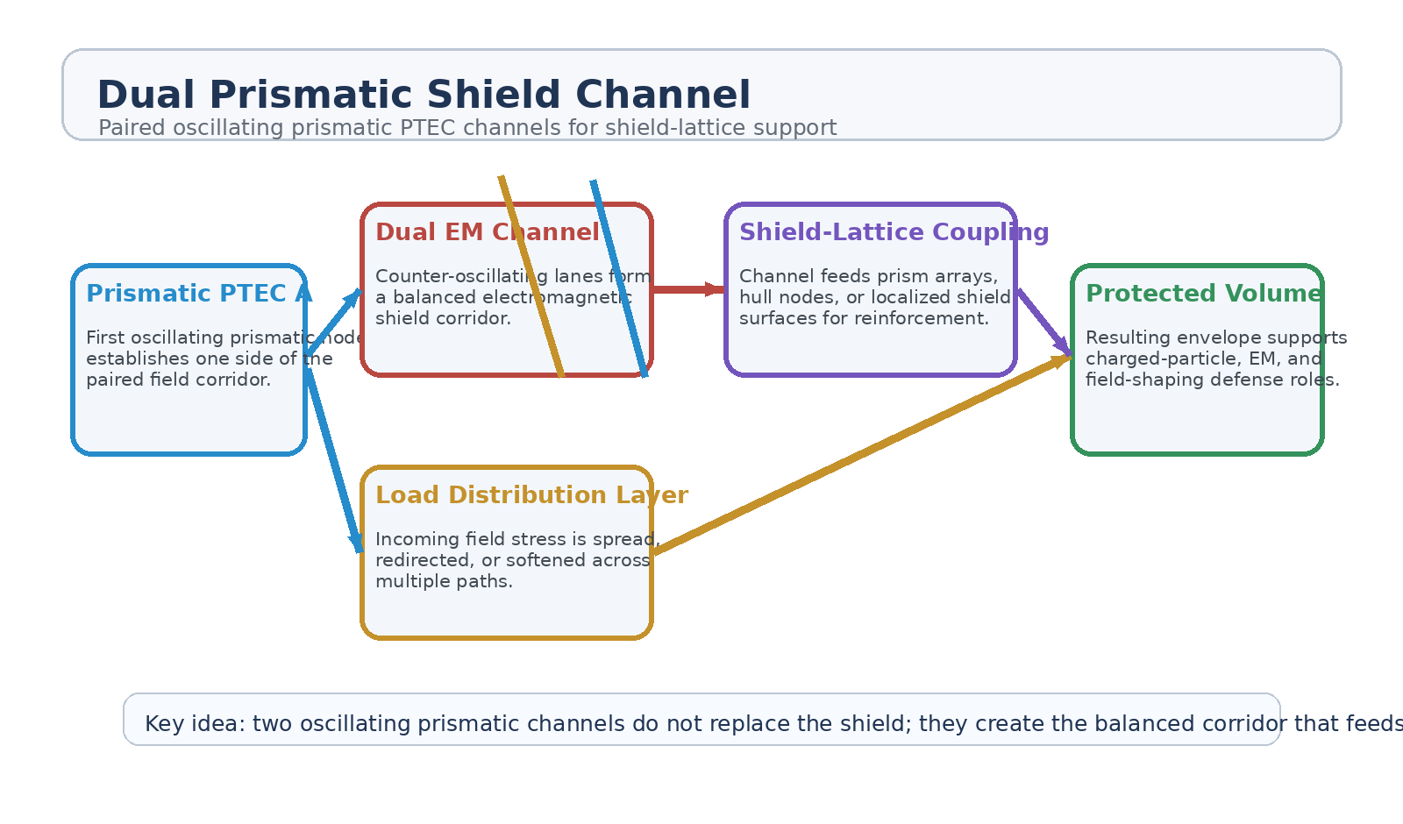
Figure 1. Dual Prismatic Shield Channel architecture with paired prismatic nodes, dual EM corridor, load distribution, shield-lattice coupling, and protected volume.
1. Concept Thesis
The central idea is that shielding becomes stronger when the field does not rely on a single lane. Two prismatic oscillation sources can form a paired electromagnetic corridor, giving the system a way to balance load, share stress, and stabilize the larger defensive envelope. The pair therefore behaves less like a single emitter and more like a managed conduit feeding a broader shield structure.
This shifts the concept from “one shield source” toward “a distributed shield corridor with built-in balancing and reinforcement.”
2. Why the Dual Channel Matters
• Creates redundancy instead of a single-field dependency.
• Allows field balancing between paired oscillation lanes.
• Improves load sharing and diffusion during localized stress spikes.
• Supports stronger coupling into larger shield lattices or hull node arrays.
• Enables localized reinforcement without assuming one uniform shield bubble.
3. Layered Architecture
Layer | Subsystem | Primary Function | Role
L1 | Prismatic PTEC A | Generates one side of the paired oscillating field corridor. | Primary lane source
L2 | Prismatic PTEC B | Generates the balancing or reinforcing side of the corridor. | Counter-lane source
L3 | Dual EM Channel | Links both oscillation lanes into a managed shield corridor. | Balanced conduit
L4 | Shield-Lattice Coupling | Feeds hull nodes, prism shells, or local reinforcement surfaces. | Distributed shield support
L5 | Protected Volume | Receives the resulting stabilized shielding envelope. | Defensive outcome

3.1 Paired Prismatic Sources
The first and second PTEC lanes should be treated as paired oscillation sources rather than duplicates. Their value lies in coordinated behavior: balancing, counter-oscillation, or reinforcement depending on how the corridor is being driven and what part of the shield network needs help.
3.2 Dual Electromagnetic Corridor
The corridor itself is the real architectural upgrade. Instead of letting the shield depend on one emitter path, the system establishes a managed conduit between two oscillating prismatic lanes. That conduit can carry, spread, and redirect field stress more coherently than a one-lane source architecture.
3.3 Shield-Lattice Coupling
The paired corridor becomes most useful when it feeds something larger: prism arrays, hull reinforcement nodes, or distributed field surfaces. In that role, the dual channel is not the whole shield by itself. It is the balancing and delivery architecture that makes the larger shield more adaptive.
4. Defensive Roles
• Support for charged-particle and electromagnetic interaction layers.
• Localized reinforcement along expected stress vectors.
• Load diffusion across shield lattices or segmented defensive skins.
• Stabilization of field behavior during transient spikes or breach conditions.
• Adaptive support for broader shield arrays rather than one static shield surface.
5. Boundaries and Realism
This concept is strongest as a field-management and shield-support architecture. It should not be oversold as universal protection against every threat class or as a complete replacement for deeper passive shielding and structural defense. Its value is in balancing, distributing, and strengthening a larger defensive lattice where field behavior matters.
• Best framed for charged-particle, EM, and field-shaping defense roles.
• Less credible as a sole answer to every radiation or kinetic threat class.
• Most coherent when paired with hull structure, segmentation, or passive protection layers.
• Should be described as a corridor and support layer, not a magic shield bubble.
6. Proof-of-Concept Build Path
Phase | Goal | Bench / Program Activity | Success Signal
P1 | Paired source demo | Drive two prismatic oscillation sources in a coordinated test configuration. | Stable paired lane behavior
P2 | Corridor formation | Demonstrate that the two lanes can be treated as a coherent managed channel. | Repeatable corridor state
P3 | Load sharing test | Introduce asymmetric field stress and observe load spreading between lanes. | Improved balancing over single-source baseline
P4 | Lattice coupling | Feed the corridor into a segmented shield or array model. | Better distributed reinforcement
P5 | Protected-volume evaluation | Measure improvement in envelope stability under transient stress. | More resilient shield behavior

7. Conclusion
Dual Prismatic Shield Channel reframes shielding as a corridor problem rather than a single-source problem. Two oscillating prismatic PTECs create a paired electromagnetic lane structure that can feed, balance, and strengthen a broader defensive lattice. That makes the concept more coherent than a one-node field source and more adaptable than a rigid static envelope.
As a white paper PoC, its strength lies in shield support: balanced channels, distributed load, lattice reinforcement, and better field management across a protected volume.
Working one-line doctrine: Two oscillating prismatic channels do not replace the shield; they create the balanced corridor that feeds and strengthens the larger defensive lattice.

